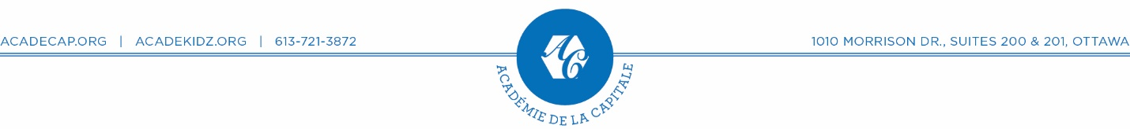
Computer Science Education Week 2017
SESSIONS AVAILABLE ON DECEMBER 4 & 7, 2017  - Minecraft Journey through Minecraft with code: Hero’s Journey  Mojang, Microsoft and Code.org | Blocks | Gr: 2+  Minecraft is back for the Hour of Code with a brand new activity! Journey through  Minecraft with code.  - Code with Anna and Elsa  Code.org | Blocks | Gr: 2+  Let's use code to join Anna and Elsa as they explore the magic and beauty of ice. You will create snowflakes and patterns as you ice-skate and make a winter wonderland that you can then share with your friends!  - STAR WARS: Building a Galaxy with Code  Code.org | Blocks, JavaScript | Gr: 2+  Learn how to program droids, and create your own Star Wars game in a galaxy far away  - DR DJ Device  Code Avengers | Language Independent | Gr: 6-8  Join Cody and Ava as they learn about Data Representation using a fun and interactive DJ Device. Discover how your name can be represented using numbers, images and sound while creating your very own colourful musical melody!  - Infinity Play Lab  Code.org | Blocks | Gr: 2-8  Use Play Lab to create a story or game starring Disney Infinity Characters  - Street Artist  Kano | Blocks, JavaScript | Gr: 2-5  Art & technology unite! Students will code with a paintbrush to make unique artwork. Will learn computer science principles, using real programming language in an engaging way.  - Learn How to Build 10 Apps in 1 Hour  Thunkables | Blocks | Gr 6+  Using language of blocks, learn to build 10 simple apps in an hour.  Please select 1 (one) session on December 4 OR 7  December 4 (Monday) 4:15-5:45 pm  ☐ A ☐ B ☐ C ☐ D ☐ E ☐ F ☐ G  December 7 (Thursday) 4:15-5:45 pm  ☐ A ☐ B ☐ C ☐ D ☐ E ☐ F ☐ G  Child’s Name: ________________________________ Sex: ☐ M / ☐ F  DOB: YYYY/MM/DD Current Grade: __ Age:__ Health Card#: ______________  Parent’s/Guardian’s Name: __________________________________________  Address: _________________________________________________________  Postal Code: ________________ Email: ____________________________  Tel-Home: (XXX) XXX-XXXX Work: (XXX) XXX-XXXX Cell: (XXX) XXX-XXXX  Emergency Contacts: Name: ______________________ Tel: (XXX) XXX-XXXX  Name: ______________________ Tel: (XXX) XXX-XXXX  Special concerns, needs, health, allergies, behavioural etc.  _________________________________________________________________ | Media Consent  There are times we photograph or videotape the children participating in camp activities. We will publish some of these pictures (i.e.: newsletters, website, Facebook, twitter, brochures, newspaper ads, etc.), without naming individual campers. Académie de la Capitale/École internationale Acadecap International School is requesting permission to use photos/videos of your child. Please note that remuneration will not be given for the use of photos/videos.  I give Académie de la Capitale/École internationale Acadecap International School permission to publish pictures of my child  Signature of Parent/Guardian  Initial or Sign  Date YYYY/MM/DD
Waiver

I hereby release and forever discharge Académie de la Capitale/Écoleinternationale Acadecap International School, its directors, its employees, agents and all persons authorized by it from any claim, damages, action or cause of action or otherwise that may result from either personal injury or property damage suffered by the said child engaging in school activities including field trips provided, however, that the school and its employees and agents exercise reasonable care.

I hereby authorize the Administrators, staff and/or excursion supervisor(s) to act on my behalf as my agent(s) to engage medical attention or hospitalization if required on an emergency basis.

Signature of Parent/Guardian
Initial or Sign
Date YYYY/MM/DD

